**GIT & GIT-HUB Task – 01**1) **git --version** – To check the git version.

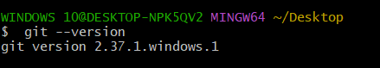

2) **yum install git** – To install git in server.

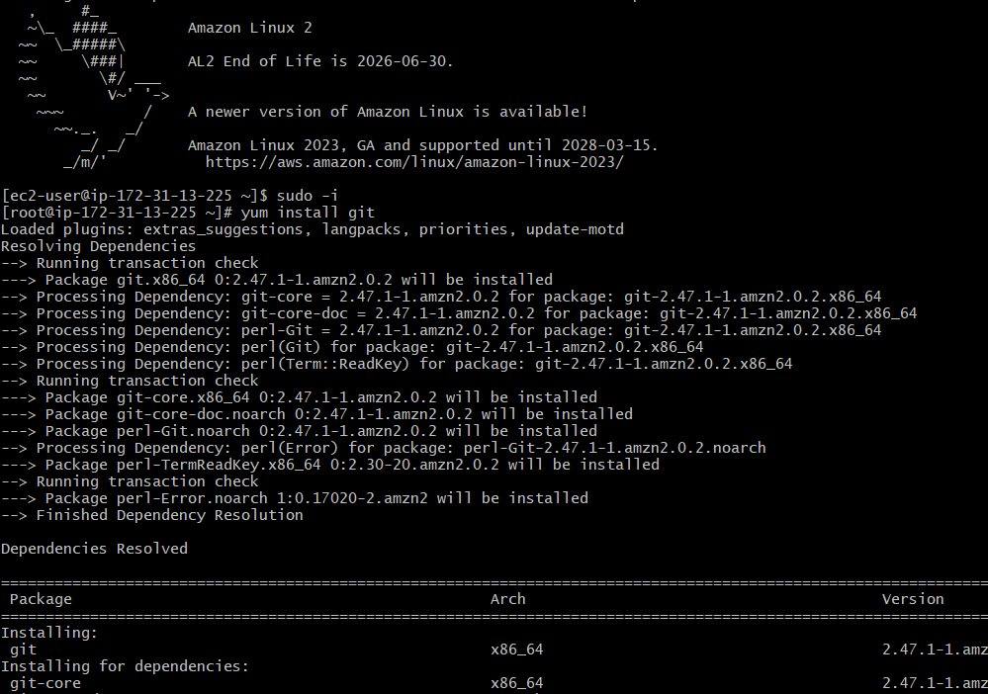

3) **git init** – For initialization, it will create .git directory.

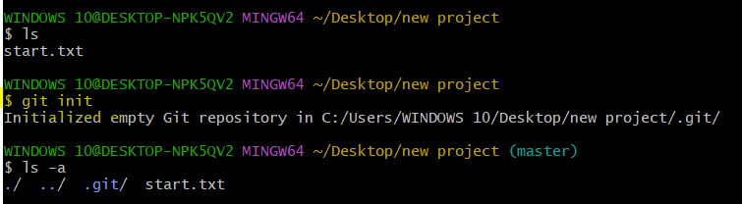

4) **git status** – To check new updates.

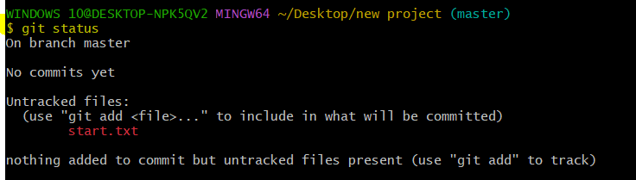

5) **git config--list** – To check git configuration.

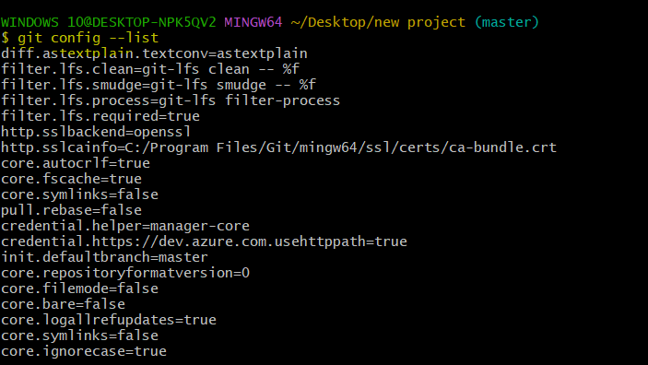

6) **git config --global user.name “Syed_Mubeen”** – To change the user name in git conf file.

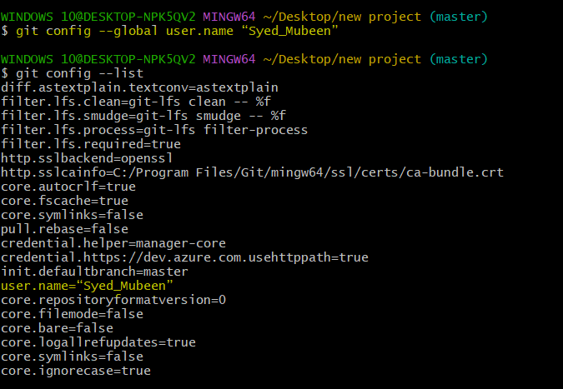

7) **git config --global user.email “**[**mubeensyed7897@outlook.com**](mailto:mubeensyed7897@outlook.com)**” –** To change the user emai in git conf file.

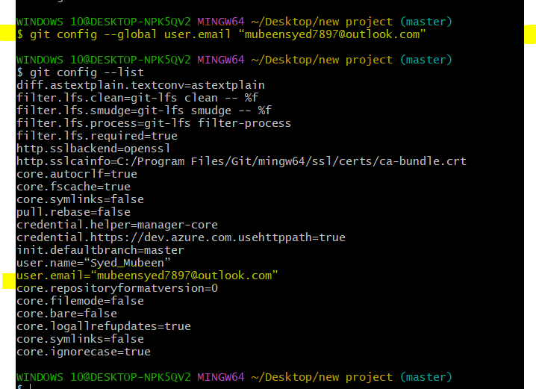

8) **git add .** – To changing files from untracking area to tracking area.

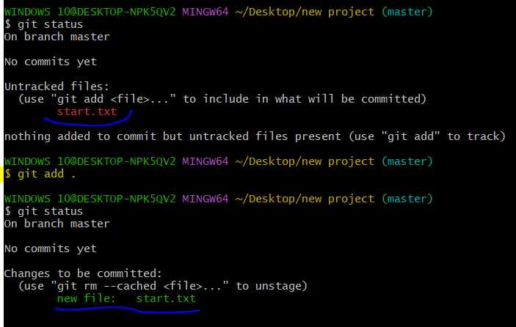

9) **git commit -m “message”** – To commit the changes.

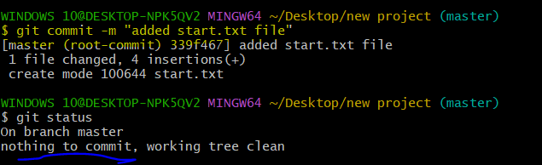

10) **git log** – To check log file with details like commit ID.

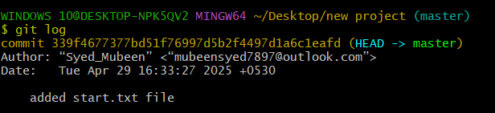

11) To create **new repository** on Git-hub.

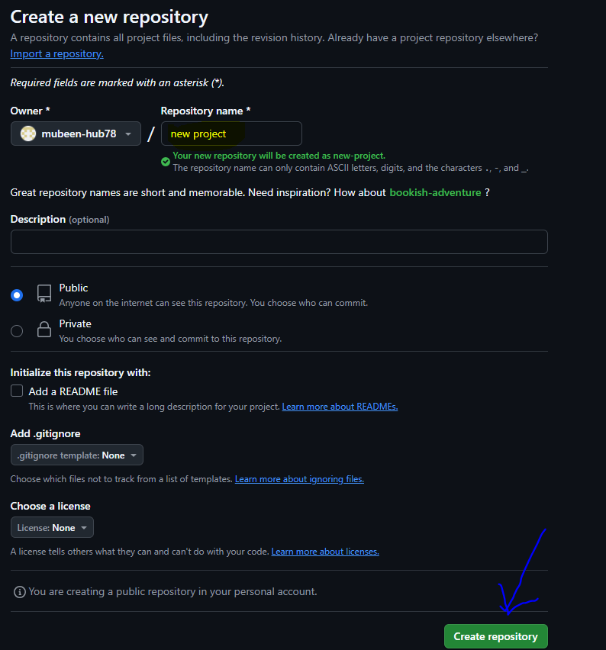

12) **New ssh key added**, copied pub key after **ssh-keygen.**

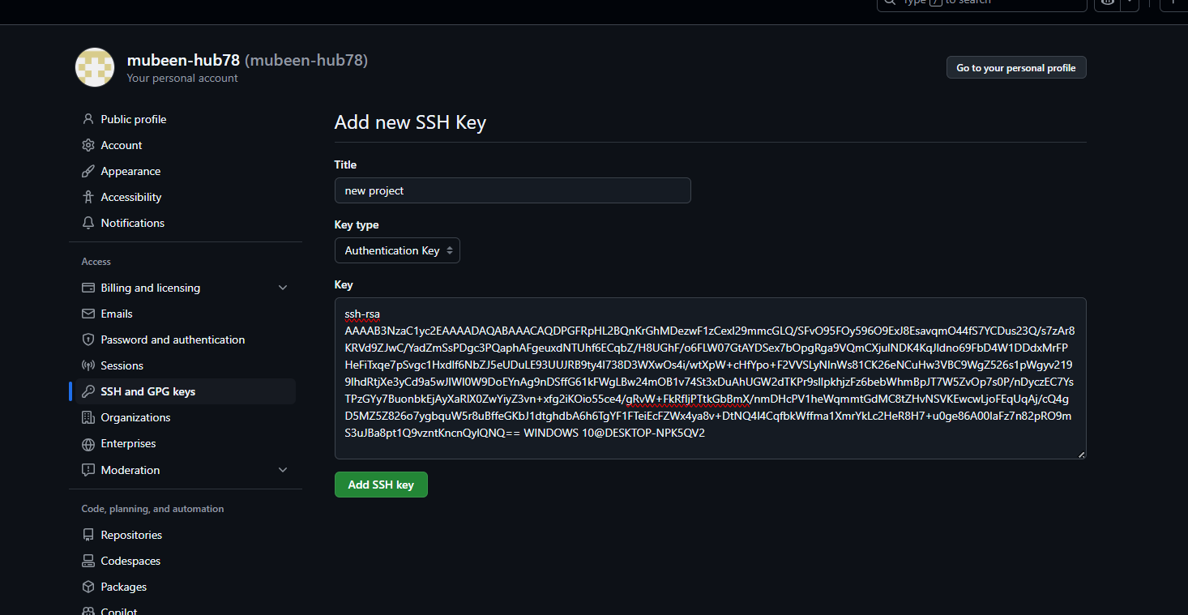

13) **git remote add origin <ssh url>** - To add destination of git-hub.

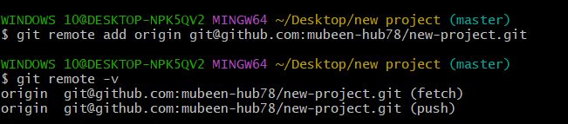

14) **git remote -v** – To check any address added.



15) **git push -u origin master** – To push code from local to Central Repository.

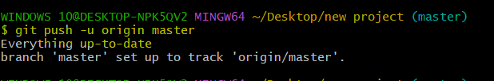

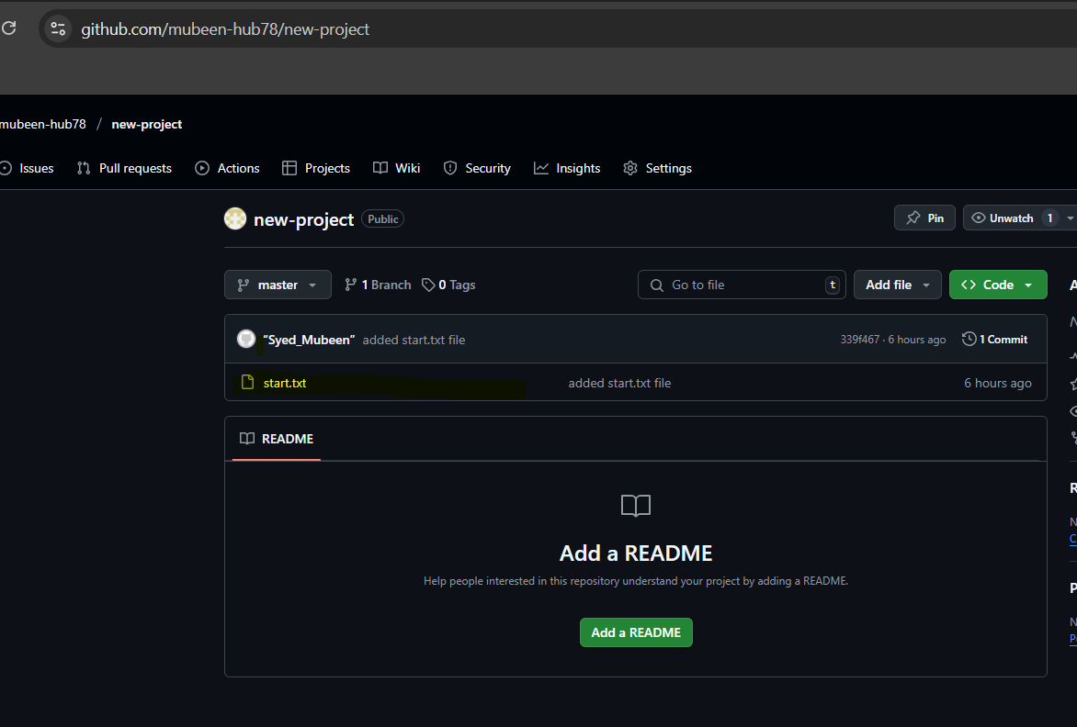

16) **git clone <ssh url>** - To download source code from central repository. It downloads the who project with all files as a directory.

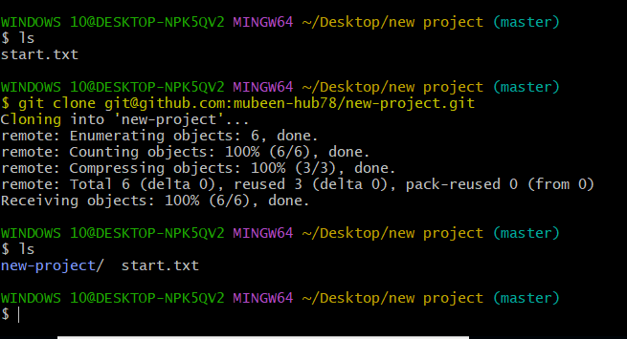

17) **git revert <commit ID>** - To revert the changes done by commit.

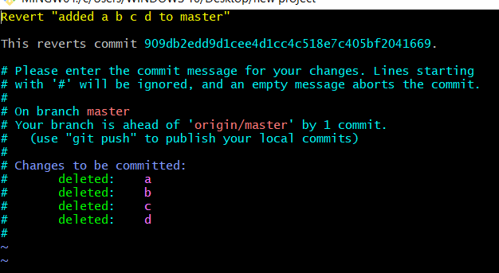

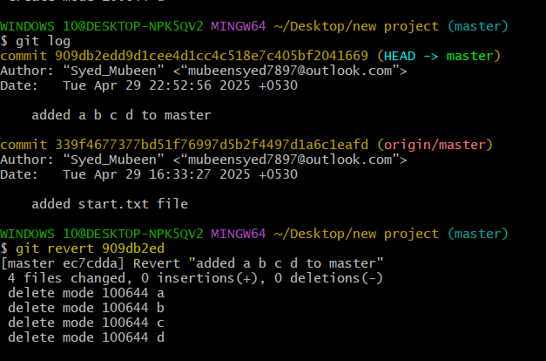

18) **git reset** – For untracking the files.

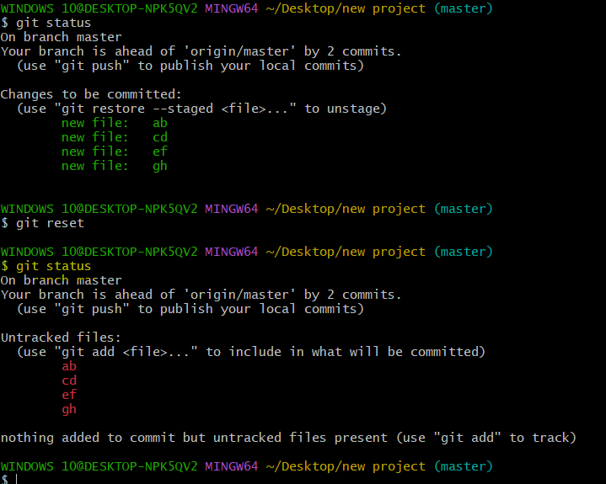

**The-End**